A000-AM,C-Taino-Cohoba Spoon-Cemi-Manatee Bone-1000 CE



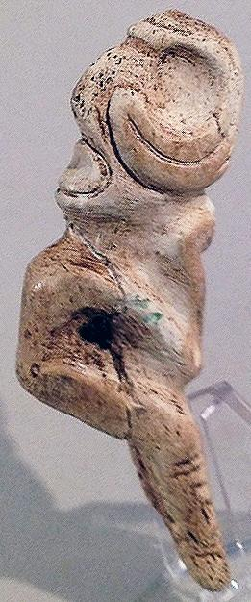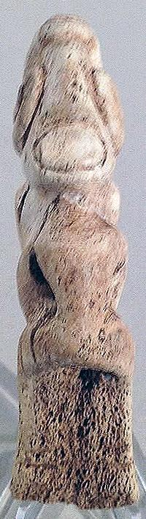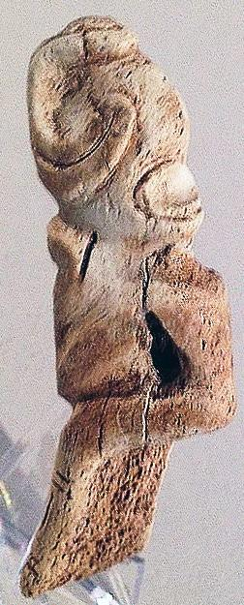

AM,C-Taino-Cohoba Spoon-Cemi-Manatee Bone-1000 CE

. Length 8.8 cm. or 3.4 in. Originally from Hispaniola, dating ca. 1000-1500 AD.

**Case No.: 18**

**Accession No.**

**Formal Label:** AM,C-Taino-Cohoba Spoon-Cemi-Manatee Bone-1000 CE

**Display Description:**

**Cohoba spoons are very rare since they were utilitarian objects used in daily rituals.** This piece is made from manatee bone and resembles a well worn spoon with an anthropomorphic figure carved on top. On the reverse another face can be seen by turning *cemi* upside down.

**LC Classification:**

**Date or Time Horizon:**

**Geographical Area:**

**Map:**

**GPS coordinates:**

**Cultural Affiliation: Taino**

**Medium:** manatee bone

**Dimensions:** 4 5/8 in. long,

**Weight:**

**Condition: original**

**Provenance:**

**Discussion:**

**References:**